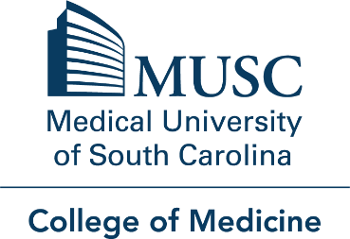

Office of Assessment, Evaluation, and Quality Improvement (OAEQI)

Research Proposal Form

Proposals will be reviewed in accordance with the COM Medical Education Research and Publication Policy. For medical education research assistance please complete this form and email to knollm@musc.edu
Contact Information:
Name of Principal Investigator:
Email address:
Phone:
Please choose your current designation: ☐ Student ☐ Faculty ☐ Staff
*Note: If student must have a faculty mentor

Faculty Rank or Faculty Mentor Rank: Faculty/Mentor Department:

Other authors or collaborators (please list):

General Proposal Information:
Describe your proposal briefly.
Identify objectives and/or research questions.
Summarize the current literature or comment on novelty of constructs/proposal. Please include search terms you used. (Optional - If you want to publish data.)
Discuss the research method(s) and plans for analysis, if known:
Discuss the plans for this study (Research, Quality Improvement, Curriculum change):
Targeted Timeline:
Plans for publication and/or presentations:
IRB application submitted: ☐ No ☐ Yes (IRB Approval number or QI Certificate)
Proposal Considerations:
Sources of funding, if applicable:
Sources of other support (data entry, transcription, etc.) for proposal, if applicable:
Any known Conflict of Interest by any party? ☐ No ☐ Yes (describe)
Survey Proposal Information: Complete only if you are proposing a survey for study.
Describe the purpose of your survey briefly.
Summarize the current literature or comment on the novelty of this survey and questions.
Targeted Timeline for Survey:
Attach draft of survey with submission of proposal form.
Questions? Please contact Michele Knoll Watson, MA, CHES at knollm@musc.edu.

OAEQI OFFICE USE ONLY:
Date submitted: Date reviewed – and by whom:

Data approved:

IRB approval number: Academic Year:

Feedback sessions? OAEQI resources required:

