- Obtain appropriate IRB approval
  - Cold-Contact recruitment website: https://research.musc.edu/resources/sctr/about/success/recruitment/cold-contact contains all of the information on MUSC’s cold-contact recruitment process, including an IRB guidance document with instructions on what to include in your IRB application if you are planning to utilize cold-contact recruitment. A consultation with the Research Preferences Manager is available to discuss the use of cold-contact recruitment at a protocol level and can be requested by submitting a “Cold-Contact Recruitment” Consultation in SPARCRequest.
    - This SPARCRequest can be found under SCTR < SUCCCESS Center < Cold Contact Recruitment.
    - If you need a general regulatory consult for non-cold contact recruitment, please submit a SPARCRequest for a “Human Subjects Regulatory Consultation”, which can be found under SCTR < SUCCCESS Center < Regulatory Services.
  - Under “Privacy- Protected Health Information (PHI) for Research”, ensure all the elements of PHI you plan to have returned in the recruitment report are checked (i.e. Name, MRN, all geographic subdivisions smaller than a state, dates, telephone number, email, etc.) Please see screenshot below:
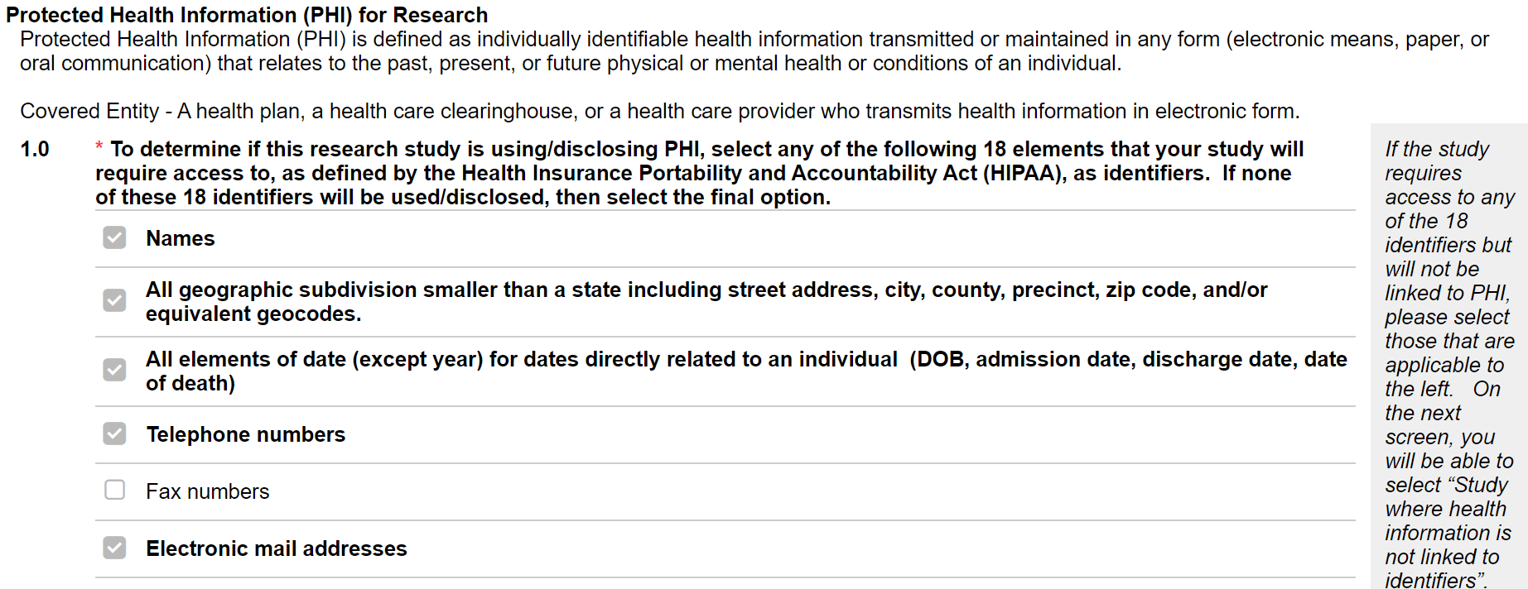
  - In addition to the PHI fields suggested above, below are additional data fields that study teams may find helpful to include on their data report. If you plan to request these fields, they would also need to be included in your IRB protocol/application.
    - Data Element of Specific Provider (ex. “Data element of dermatology provider seen most recently”). Please ensure the specific providers requested match your recruitment methods.
      - This may include PI and Co-Is listed on the IRB approved study or the PCP provider for the patient, depending on your specific approved recruitment methods.
    - Data Element of Specific Provider Department (ex. “Data element of Dr. Smith’s department” or “Data element of department where patient was last seen”)
    - Date of last visit at MUSC (this helps reach out to patients who have come to MUSC more recently)
  - If your IRB application requires you to include a start date for your medical record review, we suggest you list the start date as May 17, 2012 if you plan to include all data available in TriNetX.

- Build a query in TriNetX
  - Ensure “Study Name” includes your SPARC number in the following format: “SPARCXXXXX”
  - If you need assistance, submit a self-service feasibility SPARCRequest or access
“Design Assistance” on the left side in the TriNetX application.
- Star your final query version on the right-hand side and name final query:
  - Use the pencil to name, putting “Final” on that query version
- Go to Study Management (on the left panel) > Team > “Share Study” with Katie Kirchoff, Lynn Patterson and Alex Smith.
- Submit a Research Data SPARCRequest (https://sparc.musc.edu/)
  - “Research Data Request” can be found under “SCTR” on the homepage of SPARC
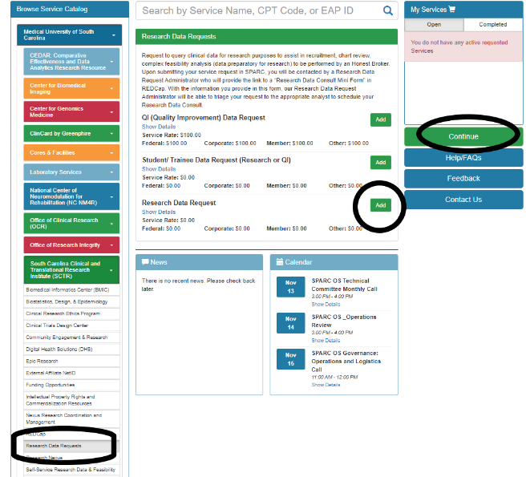
- BMIC will send a REDCap form link to complete (it should be within 24-48 hours). Here is the link that will be sent to you (https://redcap.musc.edu/surveys/?s=T7YXHADCY9)
  - Be sure to mark Yes on the question “Has a TriNetX query been created with the SCTR feasibility team for use with this data request?”
  - Suggested “Start Date” to use is May 17, 2012 to include all TriNetX data in your export
  - “End Date” should be the date you expect recruitment to end (even if that is 2-3 years from now, this will allow you to pull updated queries without having the study to be reviewed by the DRC each time)
  - In the section under “In a few words, describe what you are looking for”, list the data you would like returned and has been approved in your IRB application.
    - Refer to section 1b and 1c for a list of suggested data points.
- Once the data request has been processed, the Research Preferences Manager will reach out to schedule a consultation. All study team members, except for faculty PIs, who wish to receive access to the recruitment report, will need to be present at the consultation. For any IRB applications that have a listed mentor, both the mentor and PI must be present at the consultation.
- After the consultation has been completed, the attending study team members will receive REDCap access to the data requested, where all cold contact attempts should be recorded for the respective study.

